ST. XAVIER’S COLLEGE

**(Affiliated to Tribhuvan University)**

**Maitighar, Kathmandu**



**Computer Graphics**

**Lab Assignment #7**

**SUBMITTED BY**

**Pratik Gautam**

**013BSCCSIT029**

**4th sem/ 2nd year**

**SUBMITTED TO**

**Er. Anil K Sah**

**Lecturer**

**Department of Computer Science**

**St. Xavier’s College**

**Statement**

WAP a program to translate, rotate and scale a bitmap image in C++ programming.

**Program codes**

//---------------------------------------------------------------------------

#include <vcl\vcl.h>

#pragma hdrstop

#include <math.h>

#include "ref_rot_sca.h"

//---------------------------------------------------------------------------

#pragma resource "*.dfm"

TForm1 *Form1;

//---------------------------------------------------------------------------

__fastcall TForm1::TForm1(TComponent* Owner)

: TForm(Owner)

{

}

//---------------------------------------------------------------------------

void __fastcall TForm1::Button1Click(TObject *Sender)

{

int Tx,Ty, x,y, a,b,i,j;

Tx=StrToInt(Edit1->Text);

Ty=StrToInt(Edit2->Text);

x = Image1->Height;

y = Image1->Width;

for(i=0;i<=x;i++)

{

for(j=0;j<=y;j++)

{

a = i + Tx;

b = j + Ty;

Image2->Canvas->Pixels[a][b] = Image1->Canvas->Pixels[i][j];

}

}

}

//---------------------------------------------------------------------------

void __fastcall TForm1::Button2Click(TObject *Sender)

{

int th, x,y, a,b,i,j;

th = StrToInt(Edit3->Text);

x = Image1->Height;

y = Image1->Width;

for(i=0;i<=x;i++)

{

for(j=0;j<=y;j++)

{

a = i*cos(th)-j*sin(th);

b = j*cos(th)+i*sin(th);

Image2->Canvas->Pixels[a][b] = Image1->Canvas->Pixels[i][j];

}

}

}

//---------------------------------------------------------------------------

void __fastcall TForm1::Button3Click(TObject *Sender)

{

int Sx,Sy, x,y, a,b,i,j;

Sx = StrToInt(Edit4->Text);

Sy = StrToInt(Edit5->Text);

x = Image1->Height;

y = Image1->Width;

for(i=0;i<=x;i++)

{

for(j=0;j<=y;j++)

{

a = i * Sx;

b = j * Sy;

Image2->Canvas->Pixels[a][b] = Image1->Canvas->Pixels[i][j];

}

}

}

//---------------------------------------------------------------------------

**Translation**

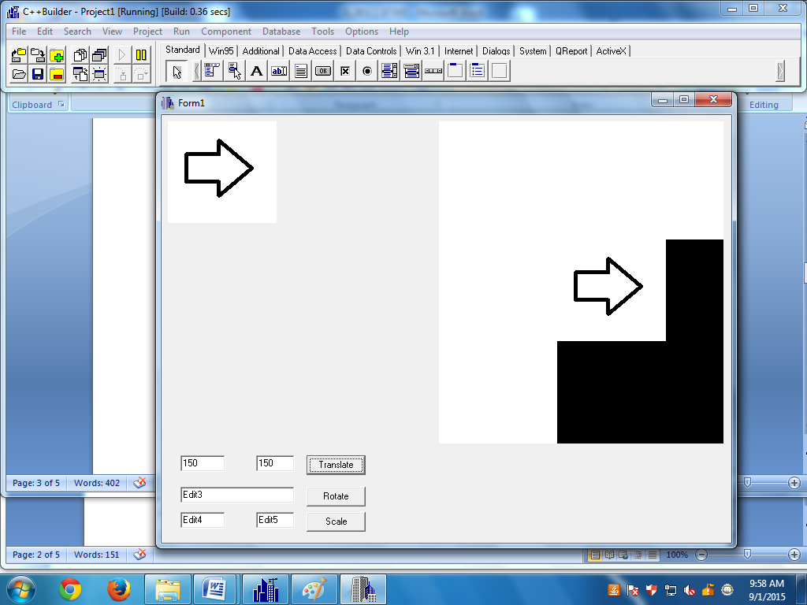

**Rotation with 100 degree about x axis**

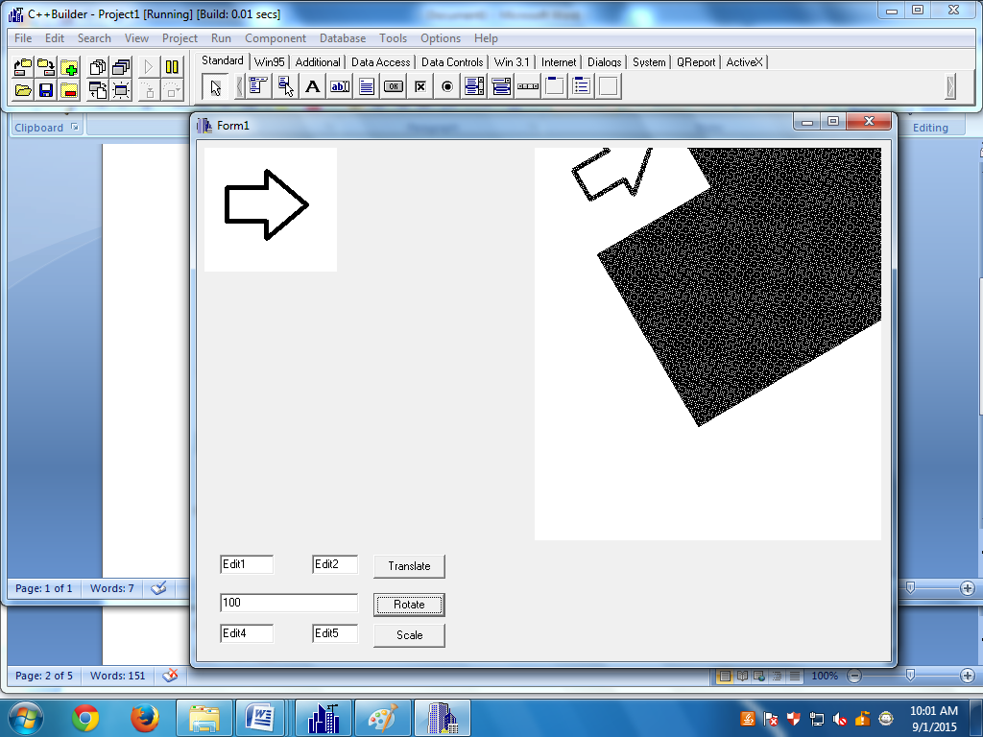

**Scaling**

